from: <https://newline.theironyard.com/cohorts/15/courses/10/projects/75>

## **Create a user directory**

Given a file of user data, create a directory of users.

Using the attached data.js file, build an Express app that works as a directory of users in the file. You should use require to get the data from the data.js file.

The amount of info each user has varies. Users with no job or company data are currently looking for work.

[Forked JavaScript file.](https://github.com/tiy-raleigh-java/Daily-Project-Create-a-user-directory)

Your directory should look like the following images. Your CSS should be in a file in the /public/ directory and be served through Express.

**Index**

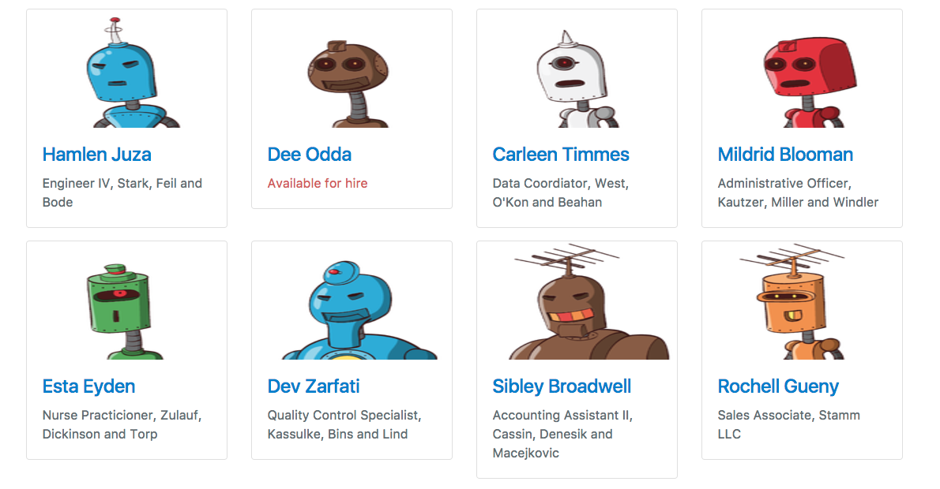

**A user with all their data**



**A user looking for work**



**A user missing educational and city data**

